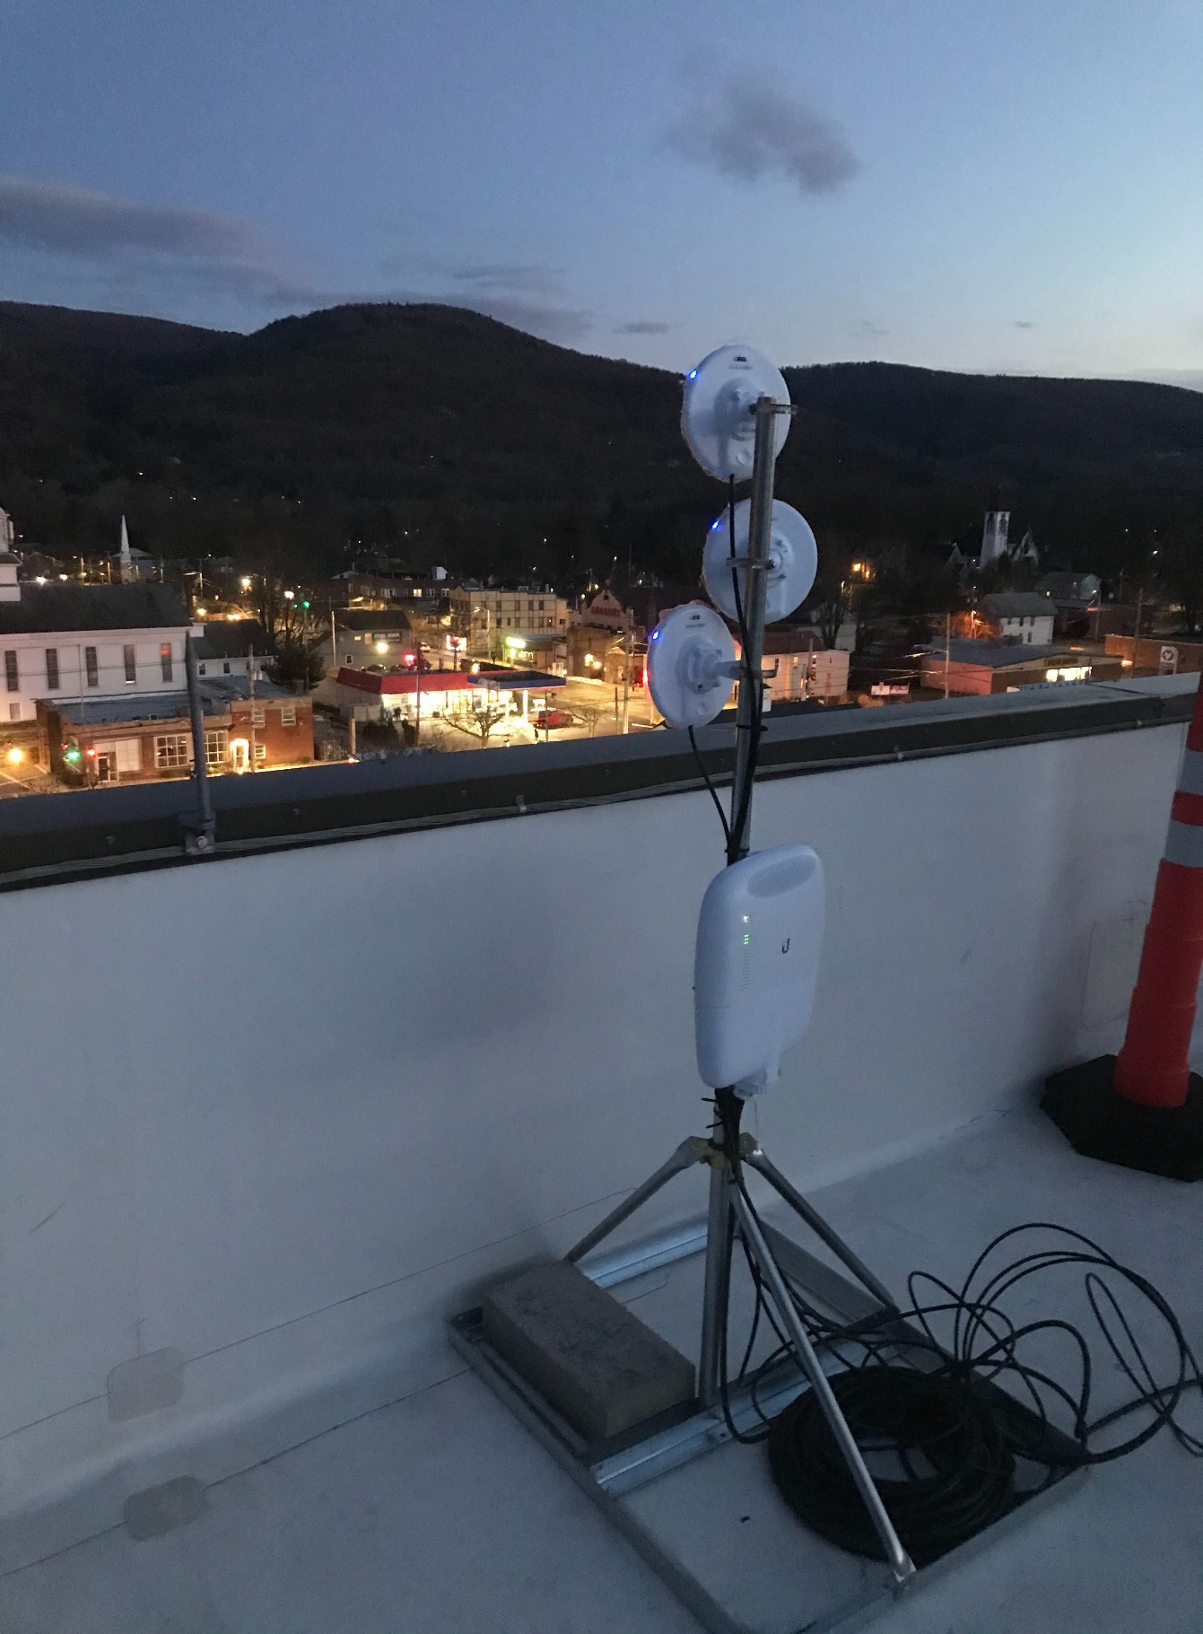**WIFI INSTALLATION** – Village Of Ellenville Municipal Building Roof